**Interim update on Data+ summer project**

**Students**

* Pablo Ortiz
* Lina Yang
* Vivek Sriram

**Graduate student mentor**

* Robert Ravier

**Volunteer data scientist**

* Ben Neely

**Faculty advisors**

* Cliburn Chan
* Megan Neely

**With help on image analysis pipeline from**

* Aronow, Bruce
* Deeptha Girish
* Vineeta Singh



**Completed**

1. Assembled database of characteristics for 4557 image files. Metadata is being used to group collections of images to process together (e.g. images from E16.5 mouse at 20X with antibodies to X, Y and Z using defined probes) – See Table 1
2. Successfully identify specific features of certain lung images by combining information from the data frame above and image analysis routines from the OpenCV package (Python binidngs) = See Figures 1 and 2 for examples of different image features identified from the same image.

**In progress**

1. Building up a database of the characteristics of all image segmentation features found in each image such as bitmap mask, xy coordinate of center, label assigned, rule-set used to identify, average R, G, B color intensities. Each image will be processed by multiple rule-sets to identify distinct segments, with rule sets chosen as appropriate based on image metadata in the data frame. For each image, there will be multiple types of image segments identified, and multiple instances of image segment type.
2. Exploratory (visual) analysis of trends over time for the features captured in 1
3. Demo web application where images dragged in will be automatically segmented with legend or mouse-over indicating assigned label (which may be wrong since none of us are lung developmental anatomists, but should be easy for experts to re-label)

**Timeline remaining**

1. July 20 (2nd group presentation to Data+ program)
2. July 29 Poster presentation and end of Data+ program

**For discussion**

1. Suggest second meeting or WebEx call with Data+ team/RTI to decide how best to make use of Data+ team efforts and possible integration with LungMAP web site
2. Possibility of paying Lina to continue with the project after Data+ ends to achieve integration with LungMAP (10 hours per week during term time)
3. Ideas for follow up projects at next years Data+
4. img_file
5. X (serial number)
6. image
7. experiment
8. age_label
9. date
10. experiment_id
11. gender
12. label
13. magnification
14. organism_label
15. platform
16. s3downloadkey
17. strain
18. path
19. x_scaling
20. y_scaling
21. researcher
22. site
23. experiment_type
24. release_date
25. color
26. probe_id
27. probe_label
28. target_conditions
29. target_molecules
30. age_group
31. age_group_label
32. cause_of_death
33. crown_rump_length
34. genotype
35. harvest_date
36. health_status
37. local_id
38. race
39. sample_id
40. sex
41. tax_id
42. weight
43. term
44. term_label
45. img_n_channels
46. img_shape
47. img_size
48. img_z_depth

Table 1: Fields in image data frame with information for 4557 images

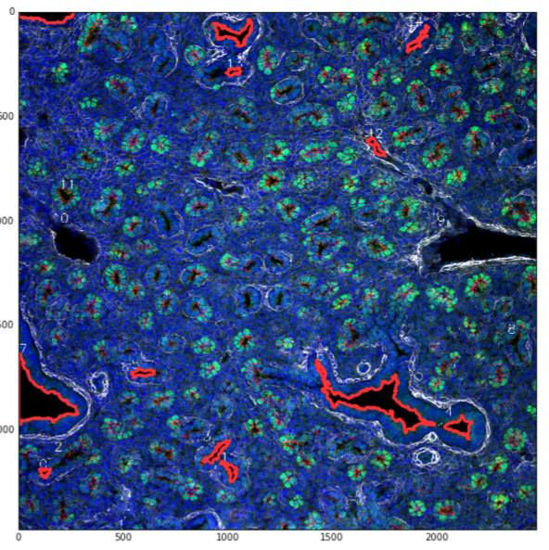

Figure 1: The red highlighted portions in this image correspond to bronchioles. They are defined by the presence of blue mesenchyme inside the white actin filaments.

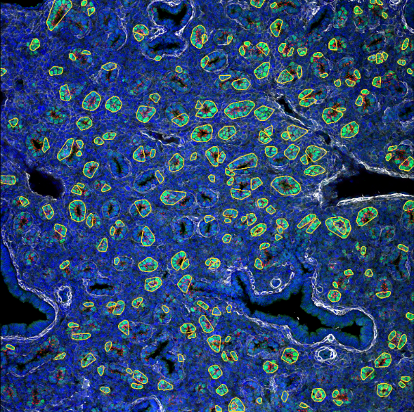

Figure 2: The circled green/red blobs correspond to acini, clusters of cells that serve as precursors to alveoli.